Name: Pranali Sonawane
Subject: CCNA
Date: 14-11-2025
Lab – EIGRP Configuration:
First, take two routers (e.g., 1841), two switches, and four PCs. Connect the routers, switches, and PCs using straight-through cables. Also, connect the serial interfaces using a straight-through cable and connect the FastEthernet interfaces using crossover cables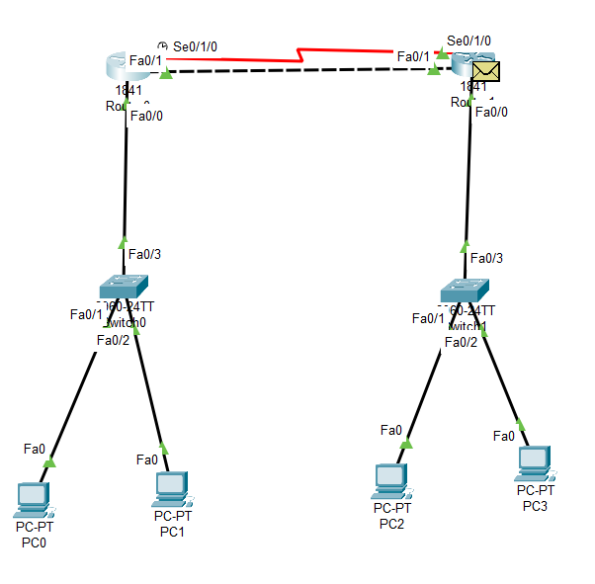
Serial cable:
Open Router 0 – CLI prompt then type following commands
Router>enable
Router#configure terminal
Router(config)# interface fastEthernet 0/0
Router(config-if)# ip address 10.0.0.1 255.0.0.0
Router(config-if)#no shutdown
Router(config-if)#exit

Router(config)#interface Serial0/1/0
Router(config-if)#ip address 30.0.0.1 255.0.0.0
Router(config-if)#no shutdown
Router(config-if)#exit

Router(config)# router eigrp 1
Router(config-router)# network 10.0.0.0 255.0.0.0
Router(config-router)# network 30.0.0.0 255.0.0.0
Router(config-router)# exit
Router#show ip route
Router#show interface serial0/1/0
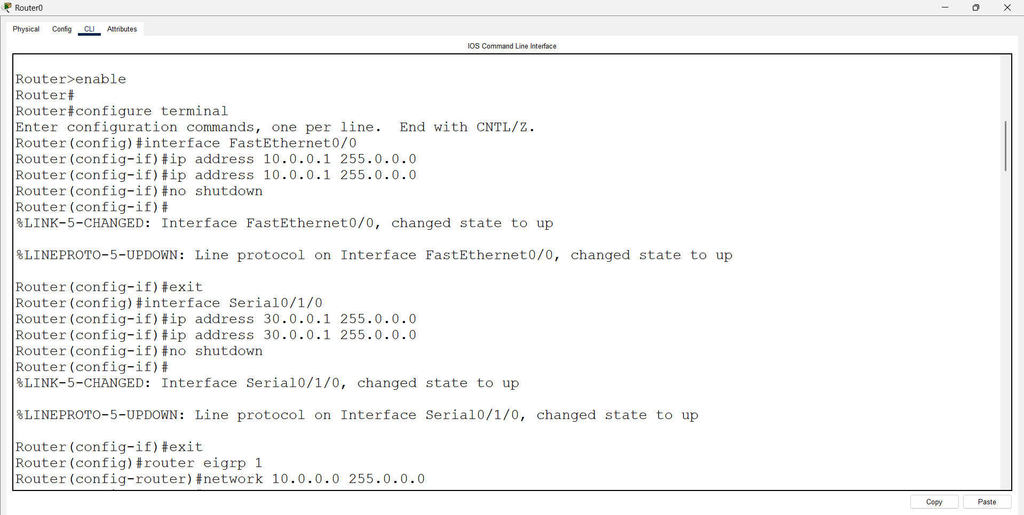
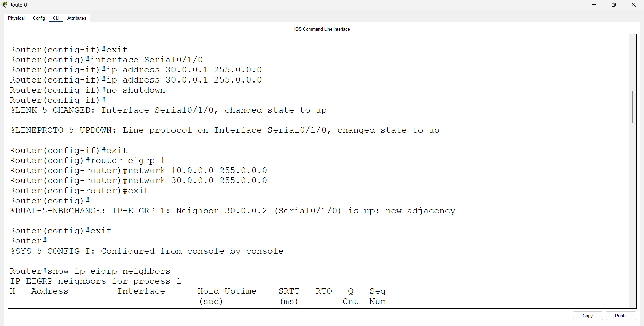
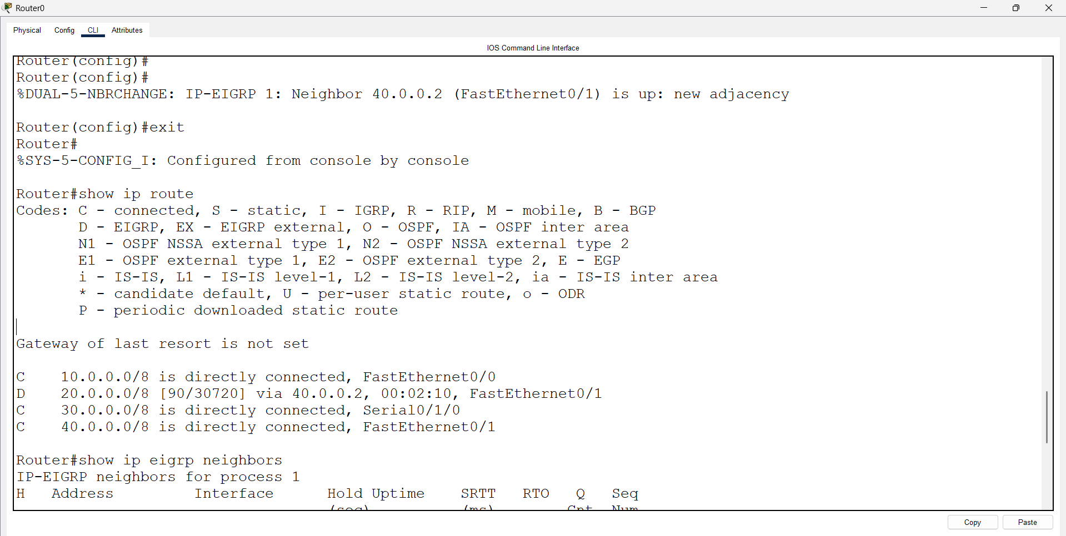
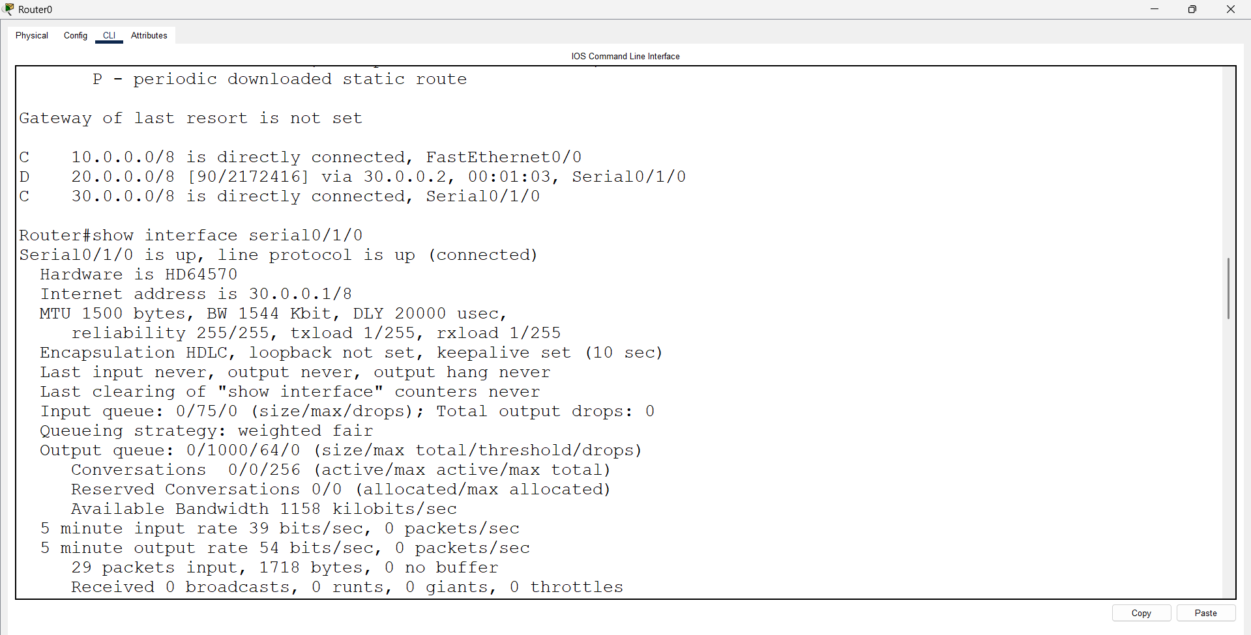

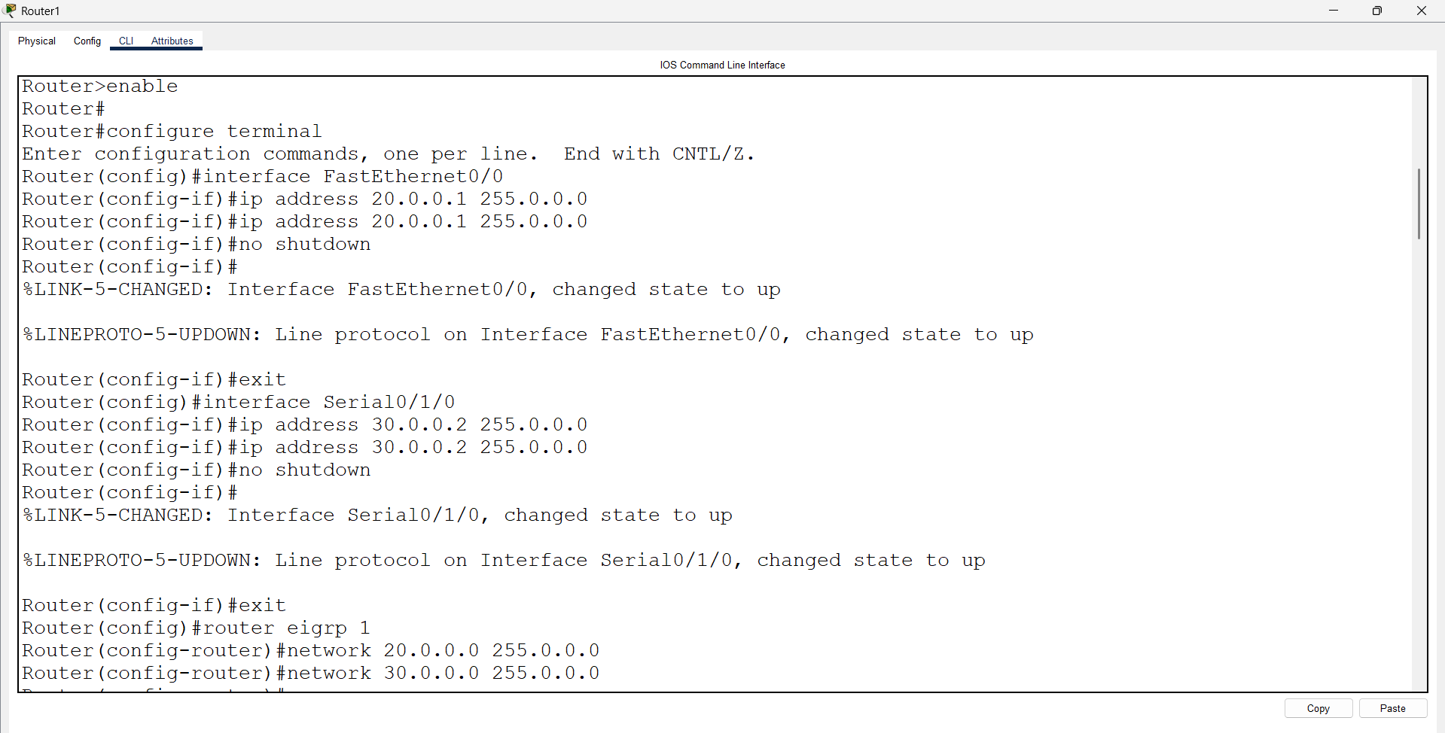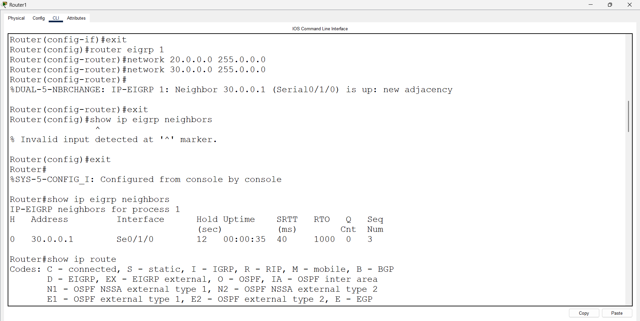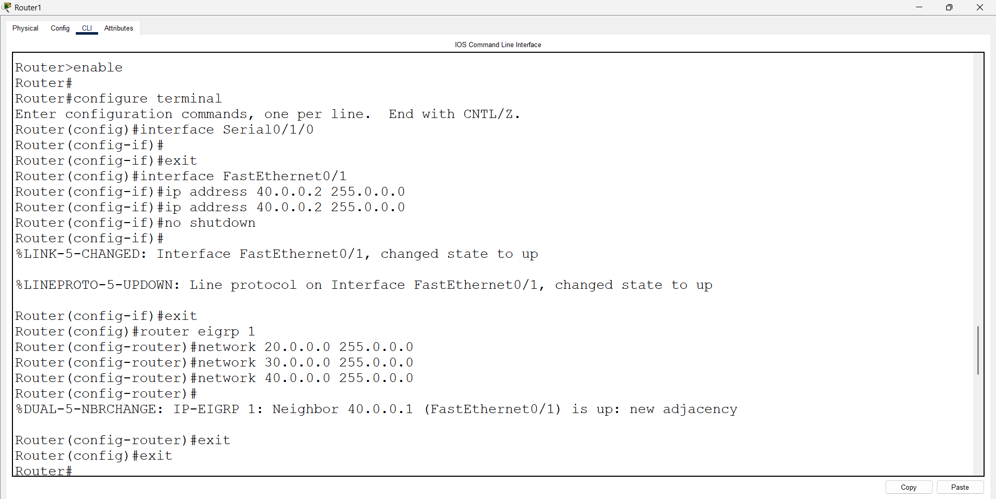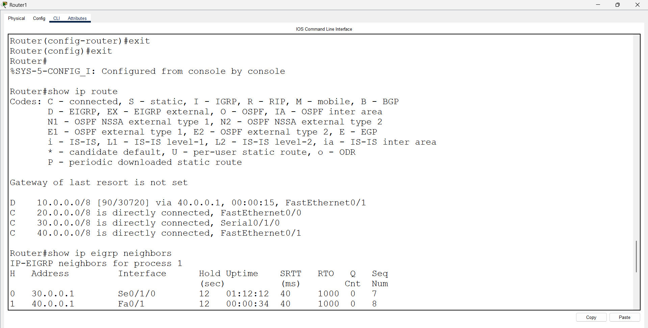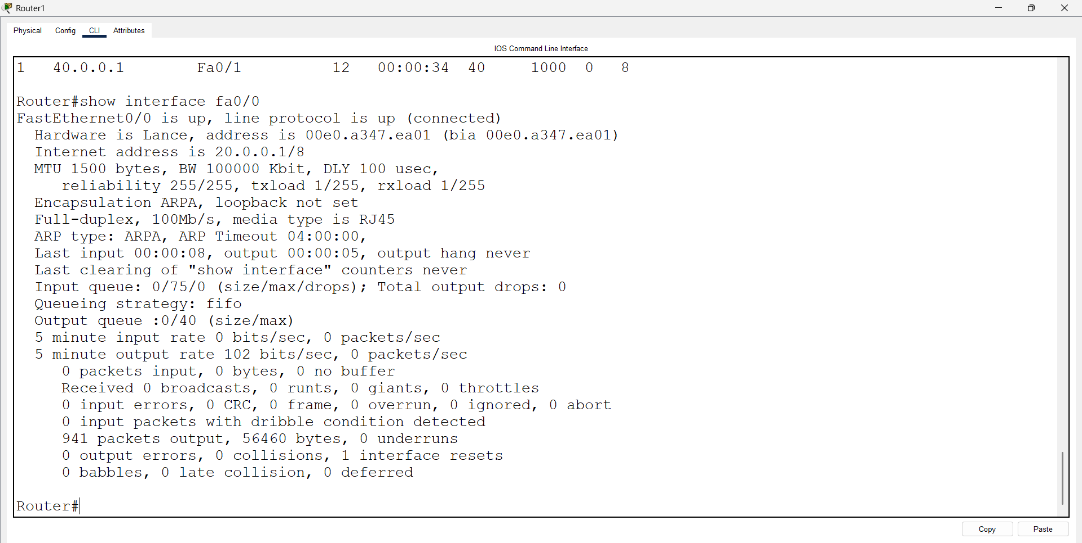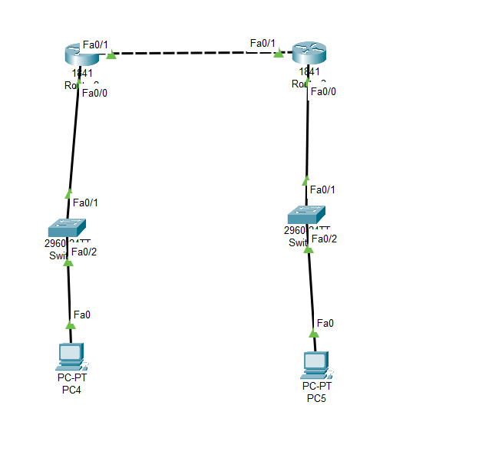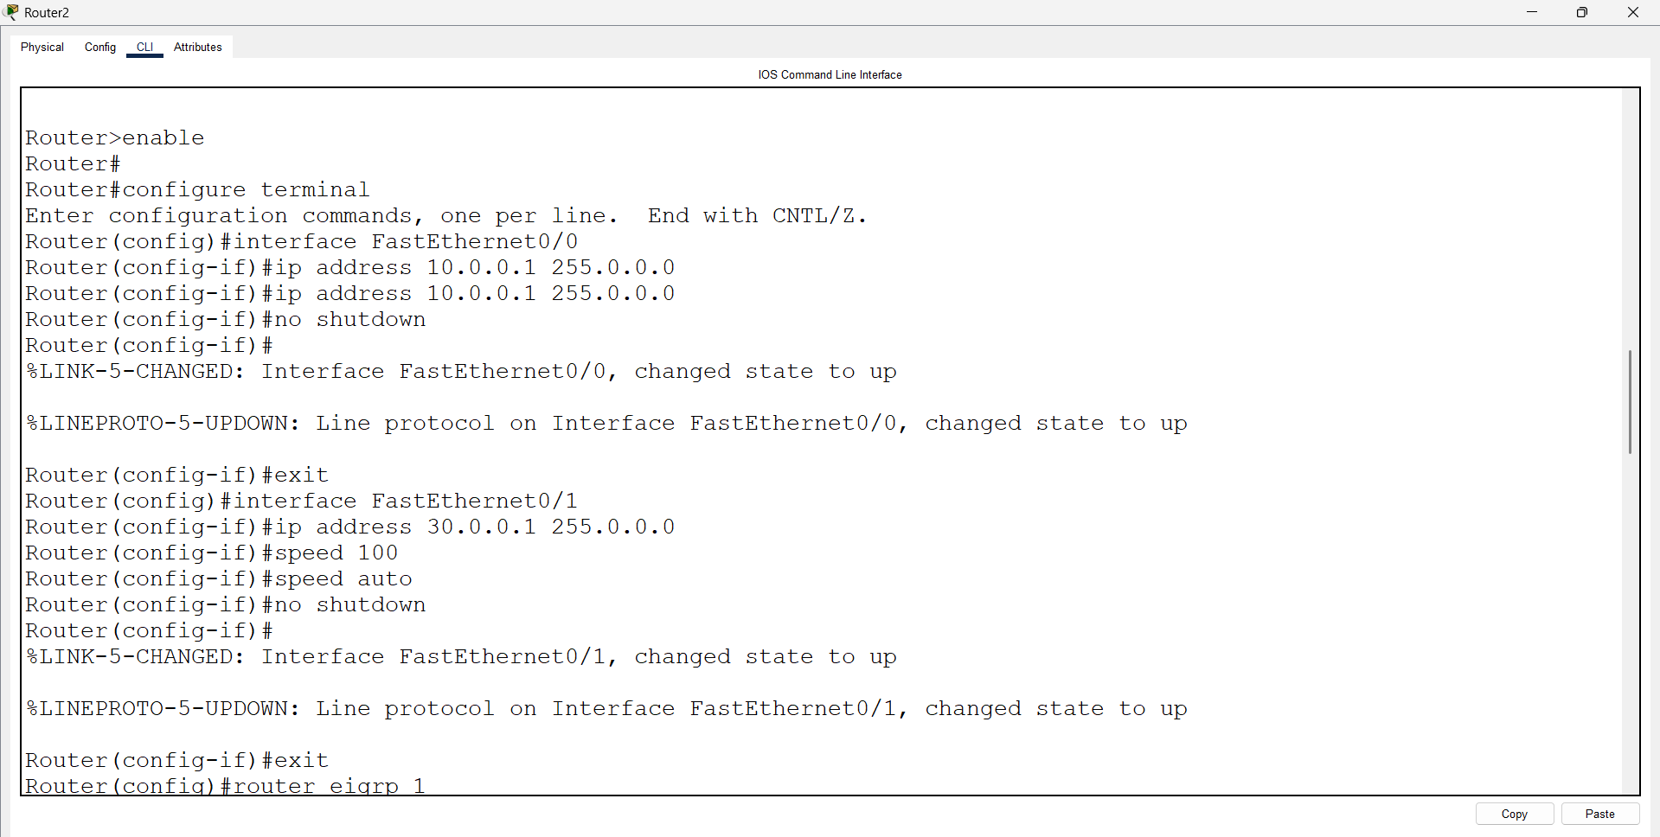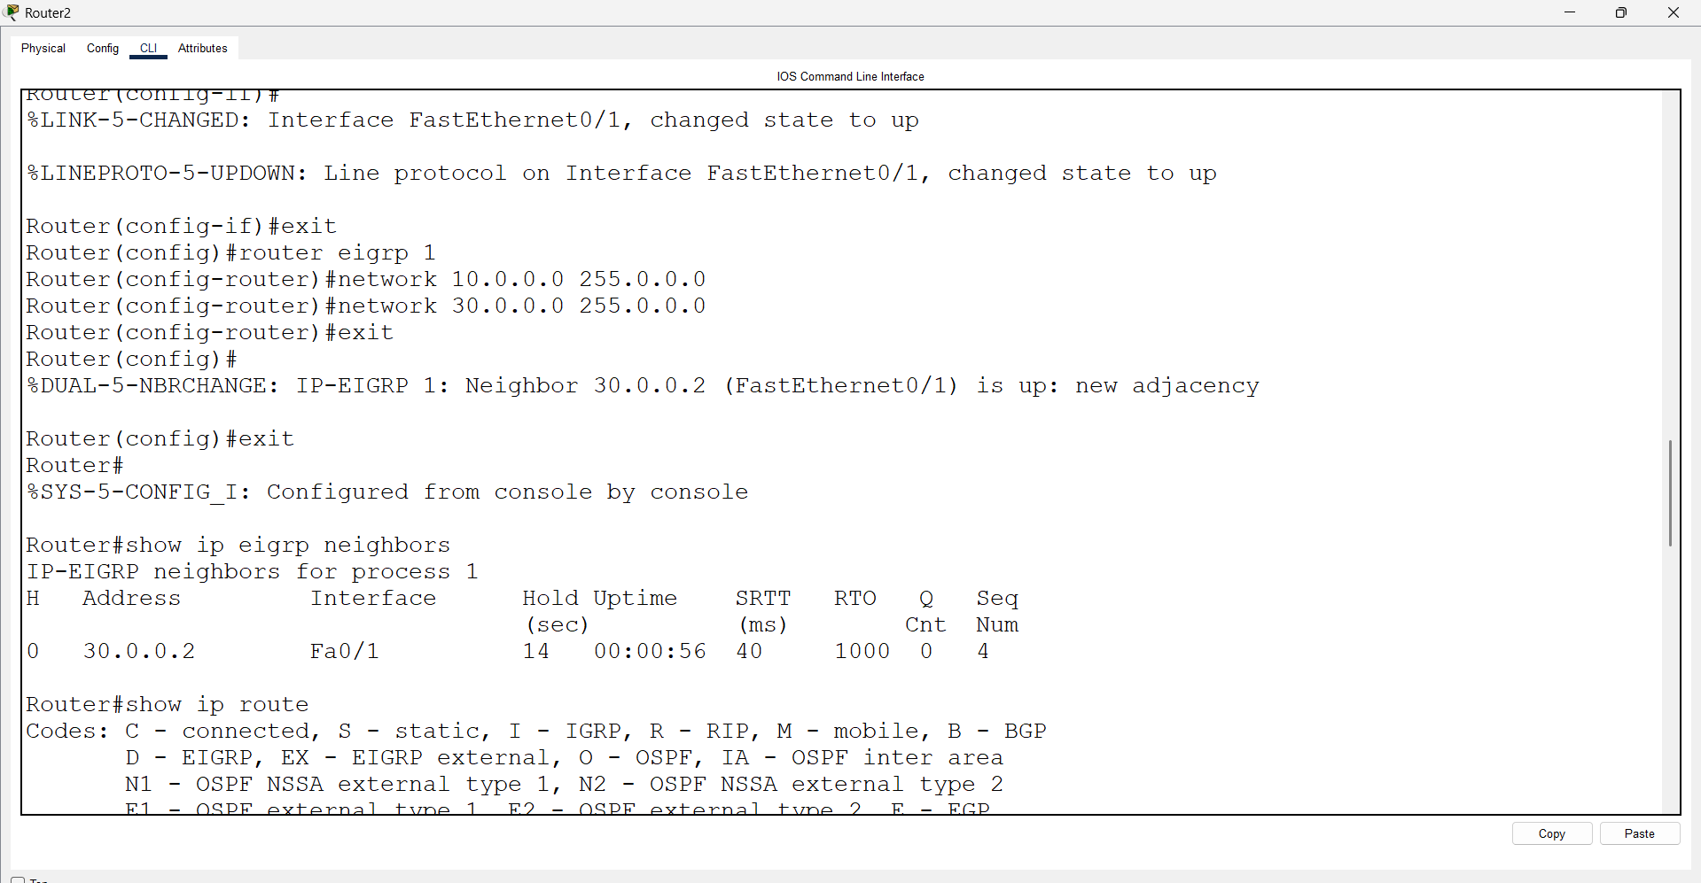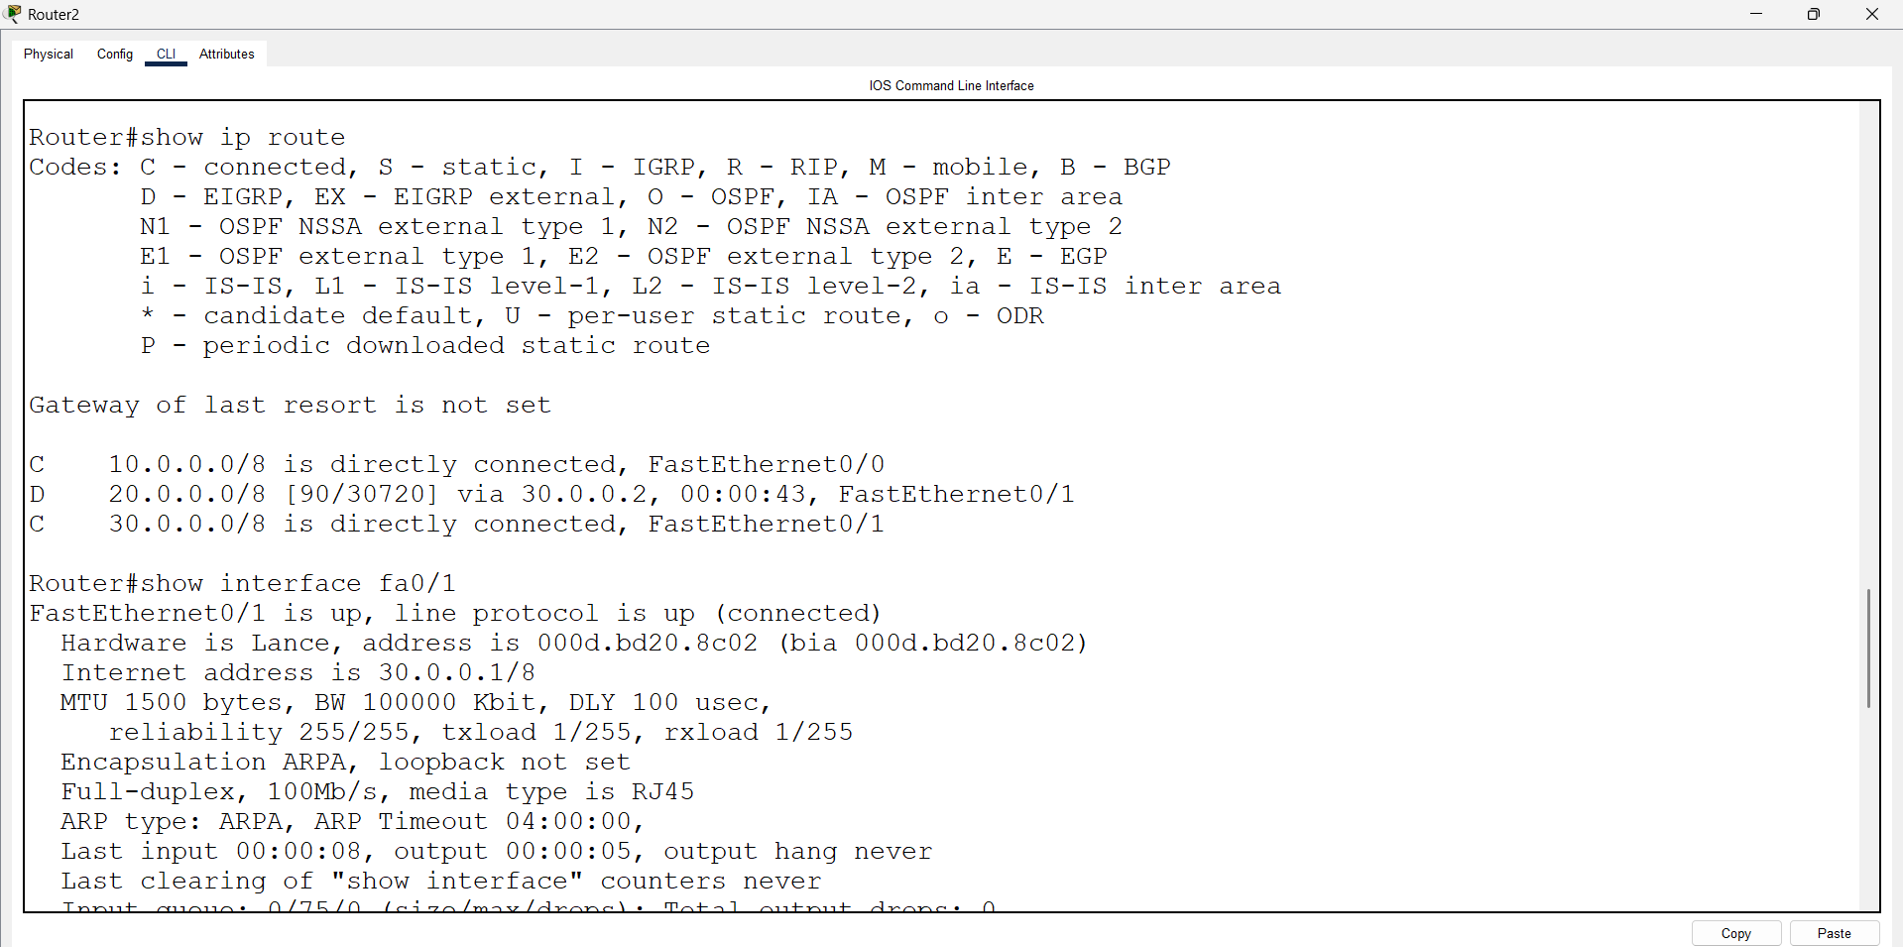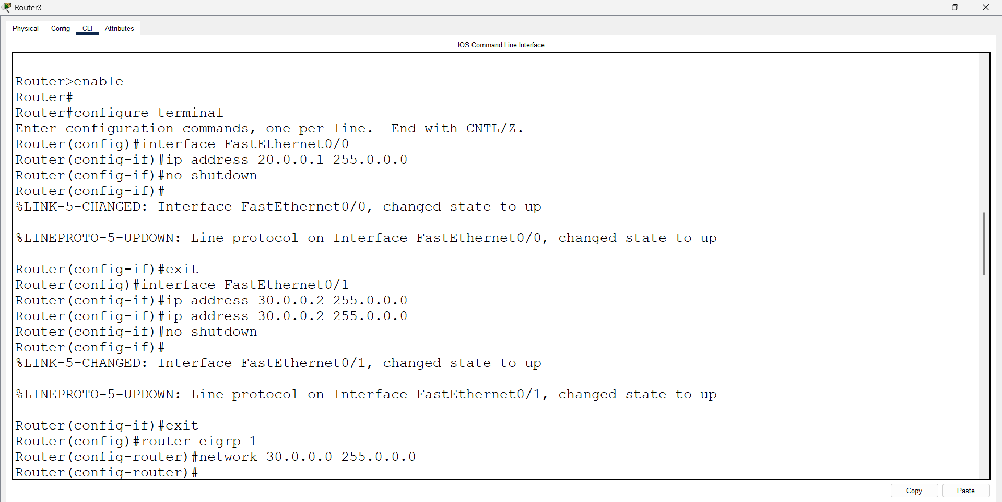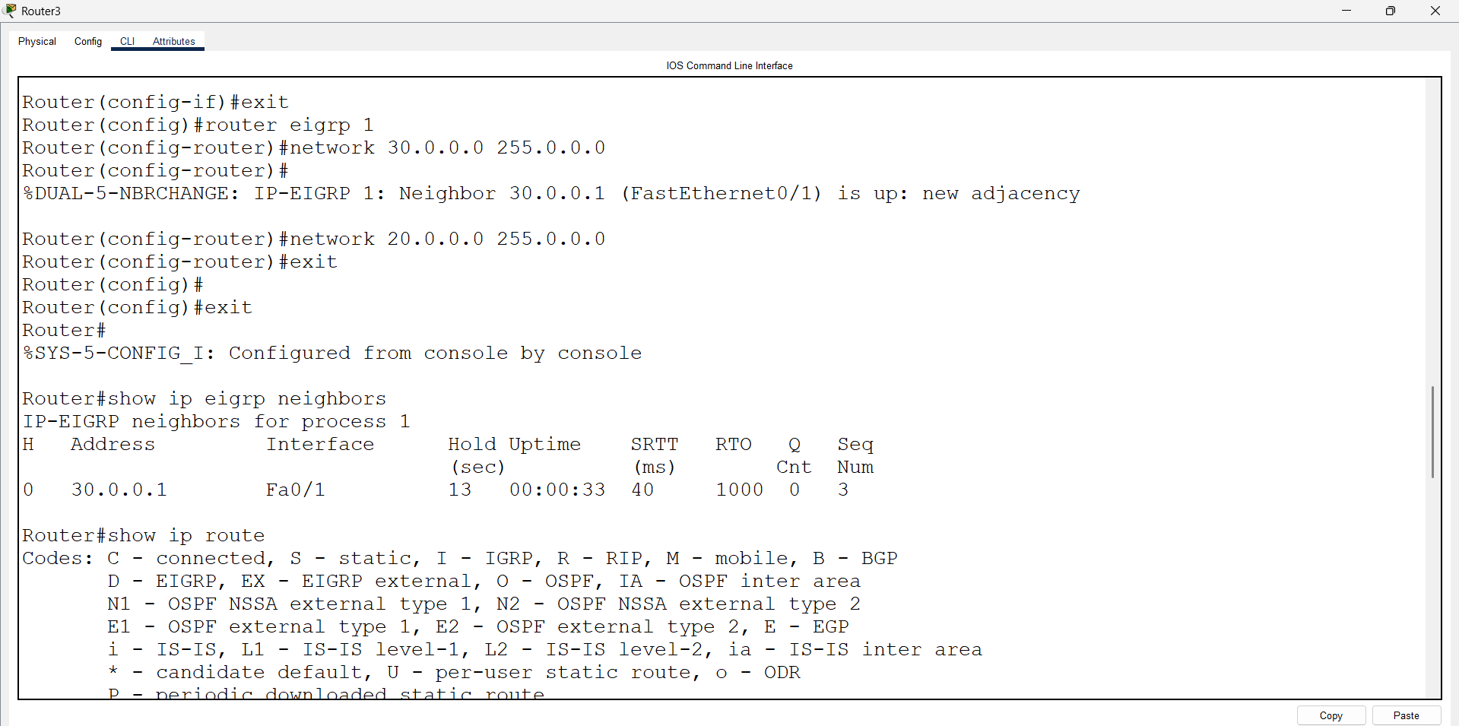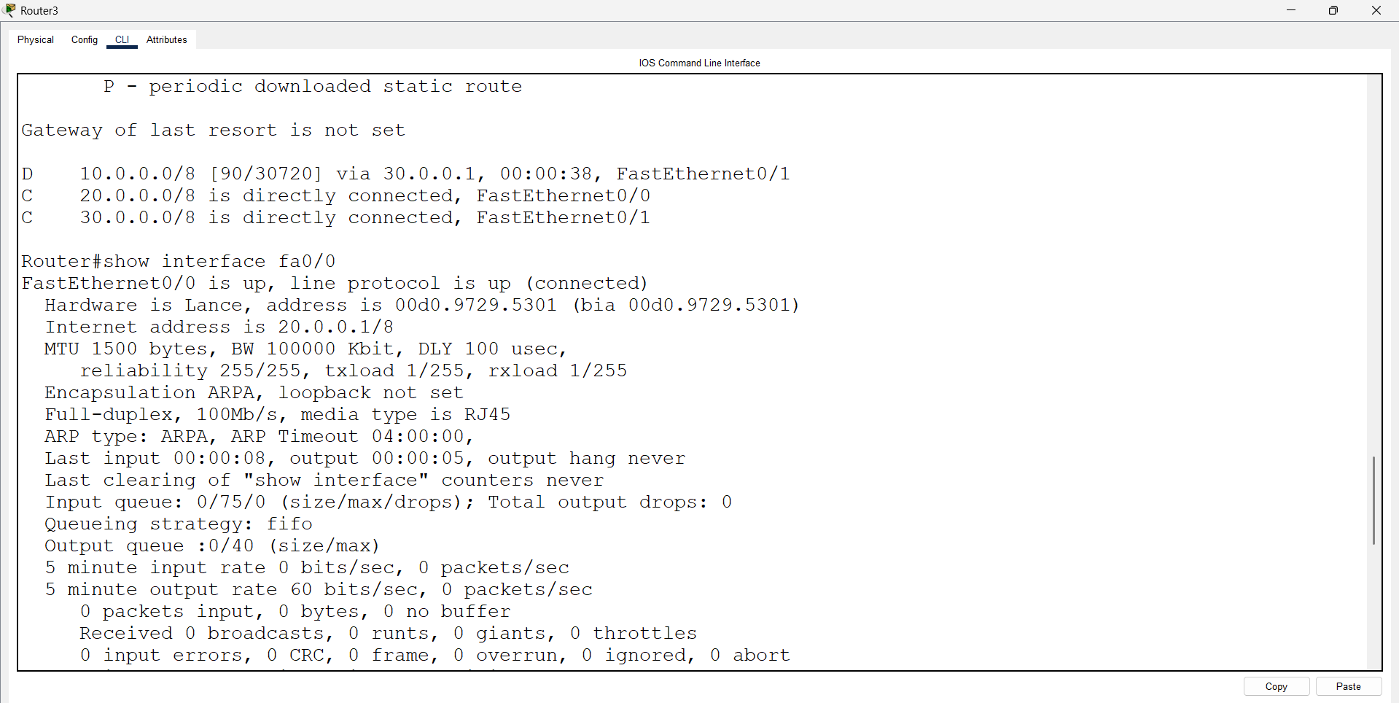

10^7/(LB+CD)*256
(10000000/1544+2010)*256=2172428
( 6476.05+2010)*256
= 2172428

LB: Fa-100000 kbps
Serial =1544

CD: se=20000/10=2000
Fa=100/10=10

